ANSWERS TO END-OF-CHAPTER AND APPENDIX QUESTIONS

1-1 (Key Question) Use the economic perspective to explain why someone who is normally a light eater at a standard restaurant may become somewhat of a glutton at a buffet-style restaurant which charges a single price for all you can eat.

This behavior can be explained in terms of marginal costs and marginal benefits. At a standard restaurant, items are priced individually—they have a positive marginal cost. If you order more, it will cost you more. You order until the marginal benefit from the extra food no longer exceeds the marginal cost. At a buffet you pay a flat fee no matter how much you eat. Once the fee is paid, additional food items have a zero marginal cost. You therefore continue to eat until your marginal benefit becomes zero.

1-2 What is the scientific method and how does it relate to theoretical economics? What is the difference between a hypothesis and an economic law or principle?

The scientific method is the technique used by economists to determine economic laws or principles. These laws or principles are formulated to explain and/or predict behavior of individuals or institutions.

A hypothesis is a “guessimate” as to the possible cause-and effect relationships between and among the facts. An economic law or principle is formulated after the hypothesis has been tested for validity.

1-3 Why is it significant that economics is not a laboratory science? What problems may be involved in deriving and applying economic principles?

Because the world of reality is cluttered with innumerable interrelated facts, researchers must be highly selective in gathering information. They must determine which facts are relevant to the problem under consideration. But even when this sorting process is complete, the relevant information may at first seem random and unrelated.

The economist seeks principles—generalizations about the way individuals and institutions behave. Deriving principles is called theoretical economics or economic analysis. The role of economic theorizing or economic analysis is to systematically arrange facts, interpret them, and generalize from them.

1-4 Explain the following statements:

a. “Good economic policy requires good economic theory.”

b. “Generalization and abstraction are nearly synonymous.”

c. “Facts serve to sort out good and bad hypotheses.”

d. “The other things equal assumption helps isolate key economic relationships.”

(a) Economic theories are the foundation of economic policy. Economic policy is a course of action intended to resolve a specific problem or further a nation’s economic goals. Therefore, the action taken (the policy) is effective only if the underlying theory is correct.

(b) The full scope of economic reality is too complex and bewildering to be understood as a whole. Economists abstract—that is, build models—to give meaning to an otherwise overwhelming and confusing maze of facts. Economic principles are generalizations; they are expressed as the tendencies of typical, or average, consumers, workers, or business firms. Generalizations or abstractions are of practical use because the simplification and removal of clutter make analysis of problems easier.

(c) To test a hypothesis, economists must subject it to systematic and repeated comparison with relevant facts. If real-world data confirm the hypothesis repeatedly, we have a good theory, otherwise it must be discarded and a new hypothesis developed.

(d) Natural scientists such as chemists or physicists can much more easily control experiments and test with great precision an assumed relationship between two variables. Economists have a much more difficult time trying to isolate key economic relationships. Nonetheless, the “other things equal assumption” is extremely important. Economists must test their theories using real world data, generated by the actual operation of the economy. Under these conditions “other things” do change and despite sophisticated statistical techniques, controls are less than perfect. As a result economics principles are less precise than those of laboratory sciences.

1-5 (Key Question) Explain in detail the interrelationships between economic facts, theory, and policy. Critically evaluate this statement: “The trouble with economic theory is that it is not practical. It is detached from the real world.”

Economic theory consists of factually supported generalizations about economic behavior that can be used to formulate economic policies. Economic theory enables policymakers to formulate economic policies that are relevant to real-world goals and problems that are based upon carefully observed facts.
  - To what extent do you accept the eight economic goals stated and described in this chapter? What priorities would you assign to them?

The first two parts of this question will be answered differently depending on the basic philosophy or values of the student.

Those who favor especially a high and growing standard of living should favor goals 1 (economic growth) and 2 (full employment).

Those more committed to equity, to “fair shares,” and the lessening of poverty, will probably prefer to stress goals 6 (an equitable distribution of income) and 7 (economic security). Such students should also make at least some reference to goals 1 and 2 or at least explain how they expect greater fairness in the economy to come about in the absence of a growing economy that in itself requires at least the absence of heavy unemployment.

Those most committed to free enterprise will probably mention goal 5 (economic freedom) first. But these students should not completely ignore the other goals, for freedom to change jobs or to seek one is of little use in times of high unemployment and no or negative growth. Moreover, such times can well lead to social unrest to such an extent that even the economic freedom of the wealthy is threatened.

Those concerned by the growing international indebtedness of the United States will mention goal 8 (balance of trade) but, at this stage of their studies, should not be expected to go very deeply—if at all—into the need for increasing productivity (implied in goal 3: economic efficiency) and maintaining price stability in relation to America’s trading partners in order to improve the balance of international trade in goods and services. Nor should students at this stage be expected to relate the Federal budget deficit and the related Federal borrowing abroad to the trade deficit.

With regard to the third part of this question, most students will probably agree that progress, stability, justice, and freedom are compatible with the list of goals given in the chapter. It is hard to imagine progress without economic growth and at least the absence of substantial unemployment. High inflation and the consequent arbitrary redistribution of incomes preclude stability, as does, in fact, high unemployment. Justice, in the view of most, is bound up with the goal of an equitable distribution of income, as it is defined in the chapter. And freedom, in the broadest sense, is linked with all eight of the goals—even of the eighth, if Americans wish to be free of the undue influence creditors can exert on a debtor.

1-7 (Key Question) Indicate whether each of the following statements applies to microeconomics or macroeconomics:

(a), (d), and (f) are macro; (b), (c), and (e) are micro.

1-8 (Key Question) Identify each of the following as either a positive or a normative statement:

a. The high temperature today was 89 degrees.

b. It was too hot today.

c. Other things being equal, higher interest rates reduce the total amount of borrowing.

d. Interest rates are too high.

(a) and (c) are positive; (b) and (d) are normative..

1-9 (Key Question) Explain and give an illustration of (a) the fallacy of composition; and (b) the “after this, therefore because of this” fallacy. Why are cause-and-effect relationships difficult to isolate in the social sciences?

(a) The fallacy of composition is the mistake of believing that something true for an individual part is necessarily true for the whole. Example: A single auto producer can increase its profits by lowering its price and taking business away from its competitors. But matched price cuts by all auto manufacturers will not necessarily yield higher industry profits.

(b) The “after this, therefore because of this” fallacy is incorrectly reasoning that when one event precedes another, the first even necessarily caused the second. Example: Interest rates rise, followed by an increase in the rate of inflation, leading to the erroneous conclusion that the rise in interest rates caused the inflation. Actually higher interest rates slow inflation.

Cause-and-effect relationships are difficult to isolate because “other things” are continually changing.
  - Suppose studies show that students who study more hours receive higher grades. Does this relationship guarantee that any particular student who studies longer will get higher grades?

No, not necessarily, because cause and effect are not clear. The observed relationship could largely reflect the fact that smarter students study more hours than do less able students. A less able student thus might not get better grades by studying longer, at least to the extent suggested by the graph.
  - Studies indicate that married men on average earn more income than unmarried men of the same age. Why must we be cautious in concluding that marriage is the cause and higher income is the effect?

Correlation does not necessarily mean that there is causation. The relationship could be purely coincidental or dependent on some other factor not included in the analysis. It is also possible that higher income is the variable that “causes” marriage.

1-12 (Last Word) Use the economic perspective to explain the behavior of the workers (rather than the customers) observed at a fast-food restaurant. Why are these workers there, rather than, say cruising around in their cars? Why do they work so diligently? Why do so many of them quit these jobs once they have graduated high school?

Workers at the fast-food restaurant are also engaging in rational behavior attempting to achieve maximum fulfillment of their goals. Each worker is weighing the opportunity cost of being in the restaurant rather than participating in the activity that is perceived as the next best alternative (say, cruising around in their cars).

The diligence observed is a function of their desire to maintain employment and the marginal benefit they receive from another day’s pay. Many of them quit their jobs after high school graduation because they receive more highly valued offers for the use of their time.

Chapter 1 - Appendix

1-1 Briefly explain the use of graphs as a way to present economic relationships. What is an inverse relationship? How does it graph? What is a direct relationship? How does it graph? Graph and explain the relationships you would expect to find between (a) the number of inches of rainfall per month and the sale of umbrellas, (b) the amount of tuition and the level of enrollment at a university, and (c) the popularity of a music artist and the price of her concert tickets.

In each case cite and explain how variables other than those specifically mentioned might upset the expected relationship. Is your graph in part b consistent with the fact that, historically, enrollments and tuition have both increased? If not, explain any difference.

Graphs can be used to illustrate the relationship between two sets of data. An inverse relationship is when the two variables change in opposite directions. The line is downward sloping. A direct relationship is when the two variables change in the same direction. The line is upward sloping. Statements (a) and (c) illustrate direct relationships. Statement (b) illustrates an inverse relationship. The inverse relationship is assuming that everything else remains equal.

1-2 (Key Question) Indicate how each of the following might affect the data shown in Table 2 and Figure 2 of this appendix:

a. GSU’s athletic director schedules higher-quality opponents.

b. An NBA team locates in the city where GSU plays.

c. GSU contracts to have all its home games televised.

(a) More tickets are bought at each price; the line shifts to the right.

(b) Fewer tickets are bought at each price, the line shifts to the left.

(c) Fewer tickets are bought at each price, the line shifts to the left.

1-3 (Key Question) The following table contains data on the relationship between saving and income. Rearrange these data into a meaningful order and graph them on the accompanying grid. What is the slope of the line? The vertical intercept? Interpret the meaning of both the slope and the intercept. Write the equation which represents this line. What would you predict saving to be at the $12,500 level of income?

Income  (per year)` | Saving  (per year)
$15,000  0  10,000  5,000  20,000 | $1,000  -500  500  0  1,500

Income column: $0; $5,000; $10,000, $15,000; $20,000. Saving column: $-500; 0; $500; $1,000; $1,500. Slope = 0.1 (= $1,000 - $500)/($15,000 - $10,000). Vertical intercept = $-500. The slope shows the amount saving will increase for every $1 increase in income; the intercept shows the amount of saving (dissaving) occurring when income is zero. Equation: S = $-500 + 0.1Y (where S is saving and Y is income). Saving will be $750 at the $12,500 income level.

1-4 Construct a table from the following data shown on the accompanying graph. Which is the dependent variable and which the independent variable? Summarize the data in equation form.

 | Study time  (hours)  0  2  4  6  8  9 | Exam scores  10  30  50  70  90  100

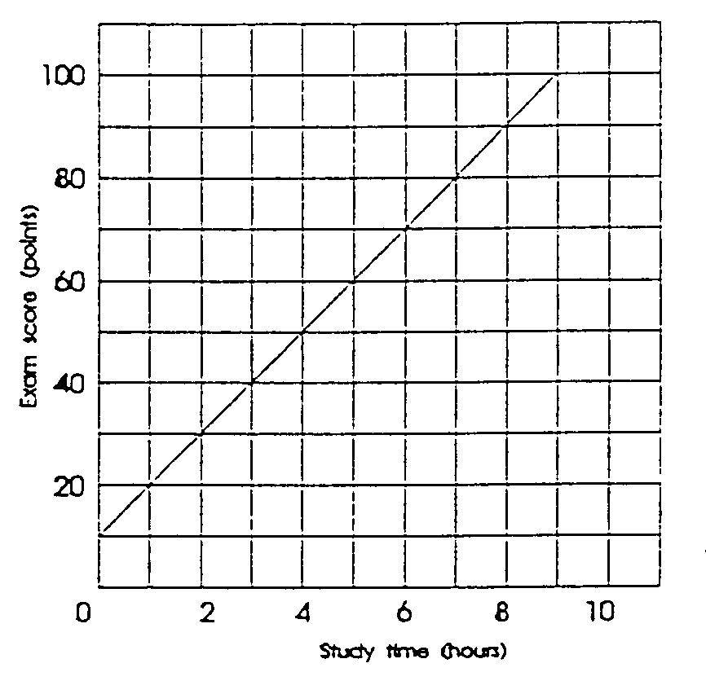
The dependent variable (the effect) is the exam score and the independent variable (the cause) is the study time.

The equation is:

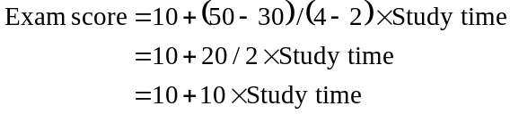

Proof:

Exam score when study time is 6 hours:

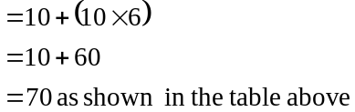

1-5 Suppose that when the interest rate is 16 percent, businesses find it unprofitable to invest in machinery and equipment. However, when the interest rate is 14 percent, $5 billion worth of investment is profitable. At 12 percent interest, a total of $10 billion of investment is profitable. Similarly, total investment increases by $5 billion for each successive 2-percentage point decline in the interest rate. Describe the relevant relationship between the interest rate and investment in words, in a table, graphically, and as an equation. Put the interest rate on the vertical axis and investment on the horizontal axis, and in your equation use the form i = a + bI, where i is the interest rate, a is the vertical intercept, b is the slope of the line (which is negative), and I is the level of investment. Comment on the advantages and disadvantages of the verbal, tabular, graphic, and equation forms of description.
Interest  rate  (in percent) |  | Amount of  investment  (billions of dollars)
16  14  12  10  8  6  4  2  0 |  | $ 0  5  10  15  20  25  30  35  40

When the interest rate is 16%, investment spending will be zero. When the interest rate is 14%, investment spending will be $5 billion. For each successive drop of 2 percentage points in the interest rate, investment spending will increase by $5 billion.

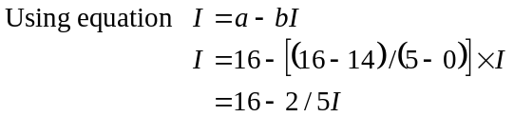

Proof: substituting data from the table when I is $25 billion, i = 16 -2/5(25) = 16 - 10 = 6

The verbal presentation can be made, but is hard to visualize. The tabular presentation is precise; all the facts are there, neatly arrayed, and it is easier to visualize than the verbal one. The graphic presentation shows at a glance the relationship between the variables and, moreover, is best for showing large changes, that is, movements of a whole curve. However, the graph requires careful drafting to ensure that it is as accurate as the table. The equation is as precise as the table and, moreover, describes all the intermediate points not set out in the table. For most people, though, the equation form is probably the hardest to visualize.

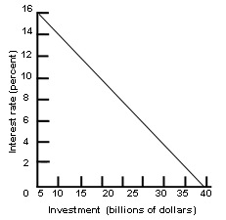

1-6 (Key Question) The accompanying graph shows curve XX and tangents at points A, B, and C. Calculate the slope of the curve at these three points.

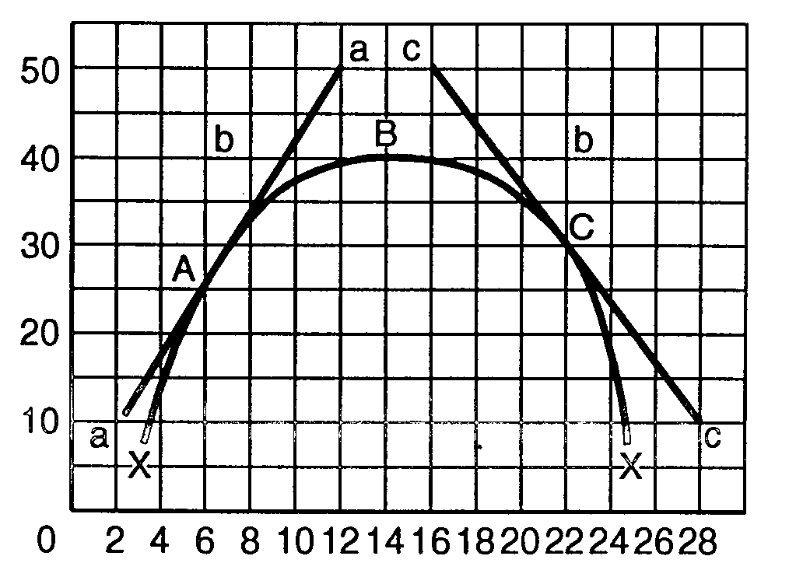
Slopes: at A = +4; at B = 0; at C = -4.

1-7 In the accompanying graph, is the slope of curve AA’ positive or negative? Does the slope increase or decrease as we move along the curve from A to A’? Answer the same two questions for curve BB’.

Slope of AA’ is positive (rising from left to right). The slope increases as we move from A to A’.

Slope of BB’ is negative (dropping from left to right). The slope increases as we move from B to B’.

The slopes of both curves are tending to infinity as they continue to move to the right.

